VPN Configuration
College of Science, Engineering, and Technology, Grand Canyon University
ITT-216: Enterprise Route & Switch
Instructor Tim Collins
Liela Pressley
5/13/2023

- Replace a office router for a 1941 router, connected it to the main office router via serial DCE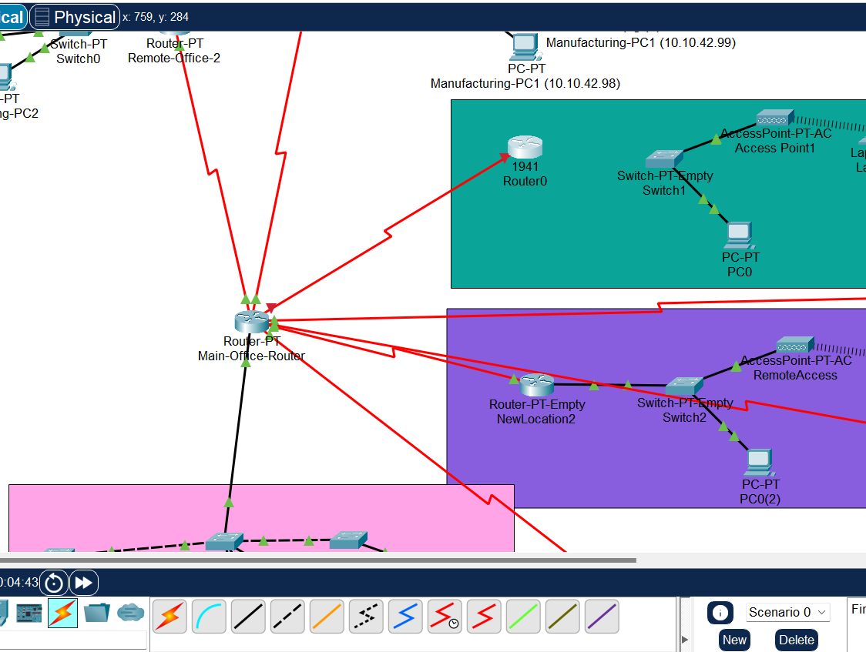
- Successfully set up a remote location, peer location, and crypto maps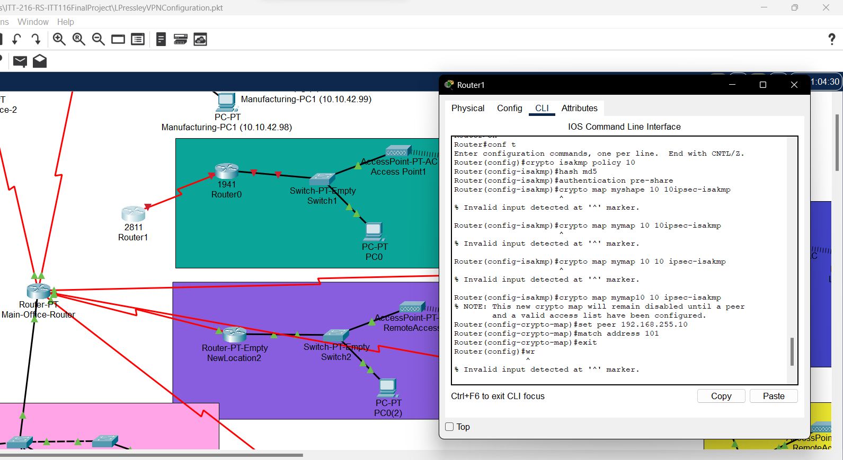
- Successfully created crypto map under port s0/3/0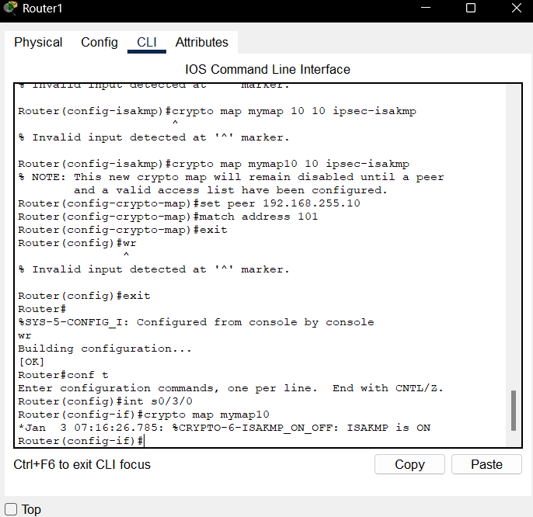
- Created access list
- 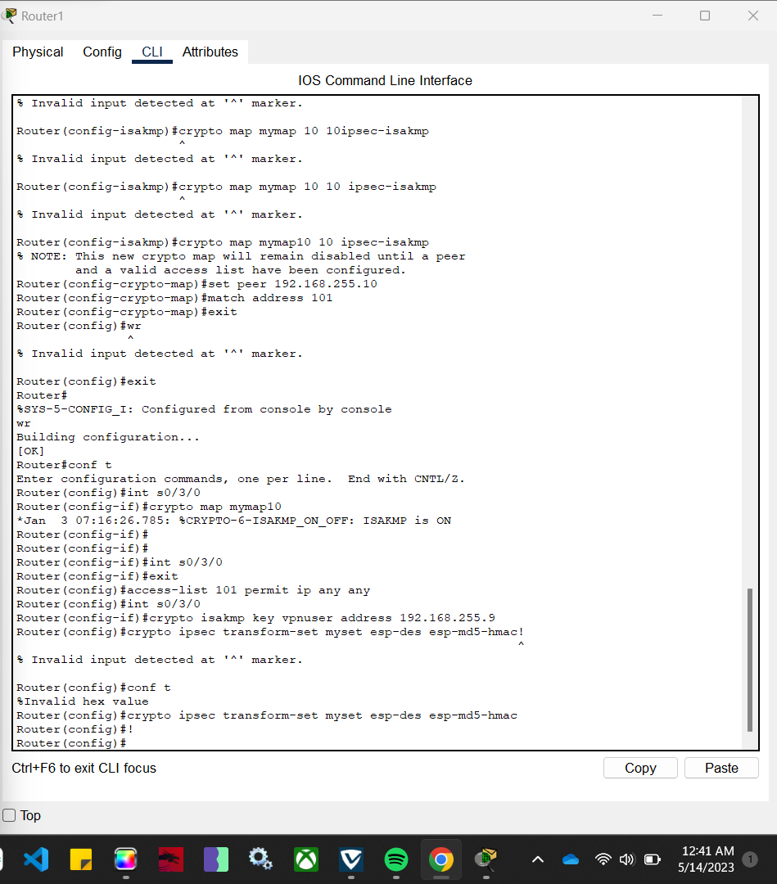
- Check that cryptomap is set up